Utah Accreditation Alliance Assessor Guide:
Assessing compliance using PowerDMS

This guide provides Utah Accreditation Alliance (UAA) assessors with information to access facility PowerDMS sites, to navigate the assessment, to assess compliance documentation, and to document deficiencies and/or corrective action needed.

- Getting Started

To conduct a UAA Assessment, you will need the following:

- The Assessor Unlock Key to the standards
- The agency’s PowerDMS Site Key
- The agency’s PowerDMS site Username and Password

To conduct a Mock Assessment, you will need the following:

1. The agency’s PowerDMS Site Key
2. The agency’s PowerDMS site Username and Password

A. Assessor Unlock Key (UAA Assessors Only)

1. Once you are assigned to conduct a UAA Assessment with an agency using PowerDMS, contact the UAA representative and ask for the Assessor Unlock Key. You may also contact PowerDMS for assistance at support@powerdms.com or 888-959-5158.

Note: The Assessor Unlock Key protects the integrity of the assessment. This unlock key acts as a password to allow members of the assessment team to change the status of the file. Agency personnel are not provided the Unlock Key!

2. PowerDMS recommends keeping the Assessor Unlock Key in a place where it can be copied and pasted into the appropriate field within the agency’s assessment. Copy and pasting the Unlock Key will expedite setting statuses to the standards as you will not have to type it each time you log in.

3. If you have problems using the Unlock Key, contact PowerDMS at support@powerdms.com or call 888-959-5158

B. Agency Site Key, Username, and Password

1. Contact the agency requesting the assessment and ensure you have been added to the assessment as UAA Assessor or Mock Assessor depending on the type of assessment you will be conducting.

Note: The agency is responsible for providing assessors with a direct link to the agency’s PowerDMS site and/or their unique Site Key.

2. Confirm the agency has added you to the assessment with the right to OBSERVE the Accreditation Manager role and the right to PARTICIPATE in the UAA Assessor role.

3. Request the agency’s PowerDMS Site Key (see instructions above)

4. Request the Username and Password from the agency

5. Log into the agency’s PowerDMS site to ensure your access.

Note: The first time you log in, you may be prompted to change your password. Change the password to something you can remember as you will use this password each time you log in.

C. Single Sign On

Some agencies use the single sign on (SSO) feature offered through PowerDMS. When you attempt to log into an agency site that uses SSO, you will be routed to the agency’s network for login instead of PowerDMS. You will not be able to log in. In such instances, use the following link to bypass the SSO. You will need to replace SITEID portion of the URL address with the SITE ID you received from the agency.

1. Copy https://powerdms.com/ui/login.aspx?siteId=SITEID&formsAuth=true into your browser’s address bar.

2. Replace “SITEID” with the agency’s SITE ID (It will not appear in red font when you copy it into your browser’s address bar).

3. Log in with the PowerDMS credentials provided by the agency.

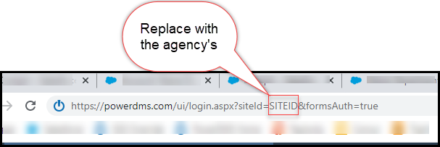

D. Logging In

1. Ensure the agency’s information appears in the login window and enter the Username and Password provided by the facility (note: If you use PowerDMS within your own organization, this username and password will be different).

2. If the agency’s name does not appear in the login window, you will need to change sites and enter the agency’s unique Site Key, then enter the username and password provided.

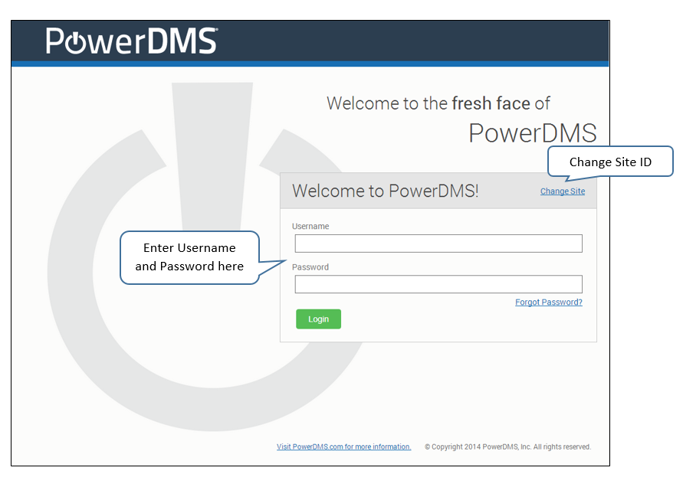

II. General Site Orientation

Every agency’s PowerDMS site has the same basic features. Most agencies customize their PowerDMS site with their logos or branding, but all sites have a home icon, Find Anything search bar, Inbox, Help menu, To Do list, and a Welcome, NAME drop-down menu. These features are defined as follows:

- Home Icon: Clicking this icon in the upper left corner of your screen returns you to the home page. This icon is always visible from any location within PowerDMS.

- Find Anything Search Bar: Typing keywords and phrases in this search field displays content the user has access to within the Agency’s PowerDMS site.

- Inbox: Contains a list of all work the user is required to complete within PowerDMS. For assessments, this work is to “set status” to the standards upon review.

- Help Menu: This drop-down menu gives you access to the PowerDMS Success Community where more information on conducting assessment can be found.

- To Do List: The To Do list creates a priority of work items found in your inbox. This list has convenient links that will navigate you directly to the assessment.

- Welcome, NAME menu: This drop-down menu is where you logout from the agency’s site.
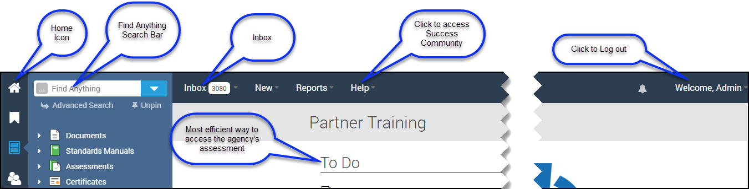

III. Accessing Standards

The most efficient way to access the assessment is to follow the link from the TO DO list on the PowerDMS homepage.

1. Once you are inside the assessment, navigate to the standard you want to review via the Table of Contents on the left pane. To access the Table of Contents, locate the four vertical dots along the left margin of the assessment. These dots are centered vertically along the left margin.
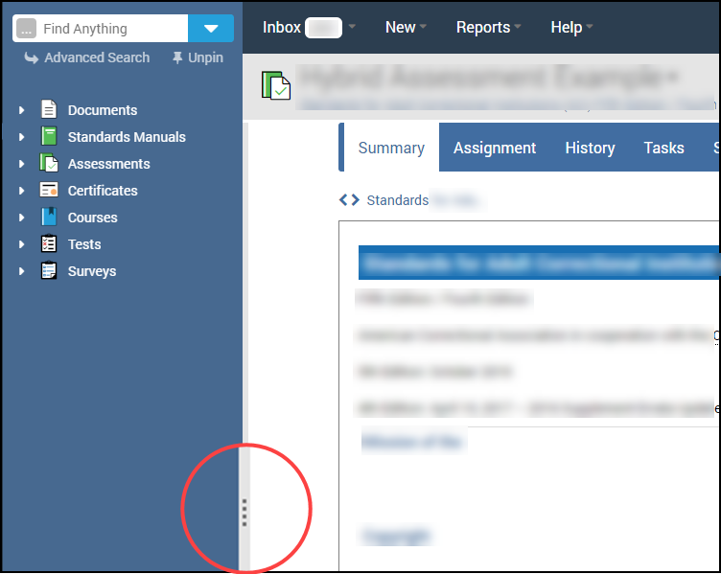

2. Click the dots to expand the Table of Contents.

3. Click on the chapter headings to access the standards.

IV. Reviewing Attachments

1. If you are a UAA Assessor, you will need to enter your Unlock Key each time you log in to the agency’s PowerDMS site. Enter (or copy and paste) the Unlock Key in the field provided and click UNLOCK.
2. Select the ATTACHMENTS tab to review the items that are attached as proof of compliance to the standard.

3. Click on the attachment’s name to view both the standard and the attachment that is used as proof of compliance. The labels beneath the attachment’s name link to highlights in the proof of compliance. Click on these labels to quickly and easily determine the agency’s compliance to the standard.

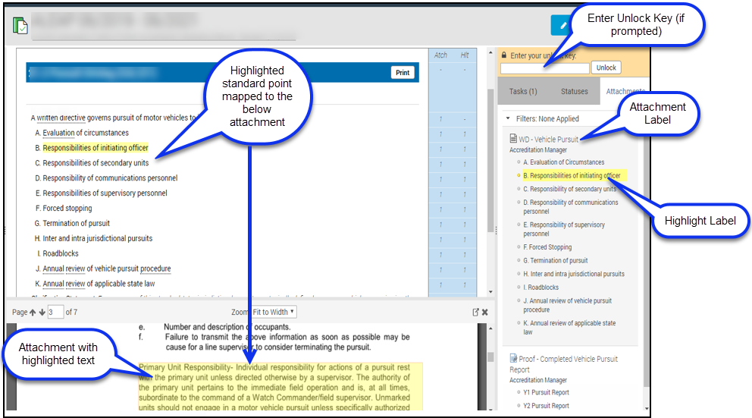

V. Filtering Standards

During your file review, you may review attachments and highlights associated with a single bullet at a time. If the agency’s project manager mapped attachments and highlights to specific bullet points on bulleted standards, PowerDMS makes examining bulleted standards quick and easy by allowing you to review each proof of compliance and all highlights specific to each bullet point one at a time

1. Select the number to the right of the standard you want to review under the “Atch” column. Only attachments mapped to the filtered bullet point will appear in the list of attachments on the right of your screen.

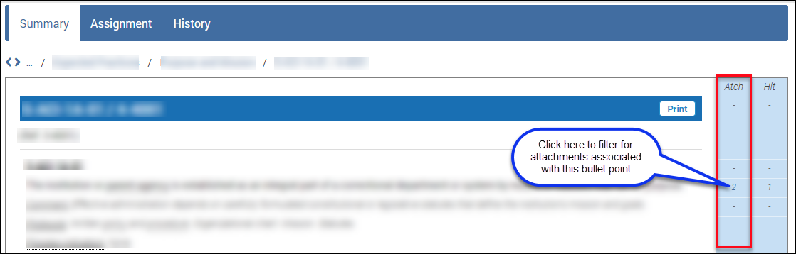

2. Click on the bold highlight labels to review compliance for that bullet point.

Note: When you filter for attachments, only attachments mapped to the bullet point will appear in the attachments list on the right of your screen. Highlights mapped to the bullet point will have bold highlight labels. Those highlights mapped to other bullet points will be grayed out.

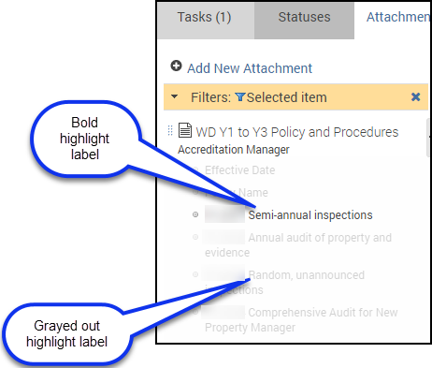

VI. Setting Statuses and Adding Simple Notes

Setting status is how you authenticate the agency’s compliance with each standard. Once you review attachments to the standard, you can set the status to indicate the agency’s level of compliance. If you need additional information from the agency or want to add a comment, document a deficiency, or recommend a corrective action, you can add a Simple Note to the standard.

A. Setting Status

1. Navigate to the Status tab of the Standard

2. Locate your role in the list

3. Select the appropriate Status from the drop-down menu

4. DO NOT enter an expiration date (the status will be date/time stamped when you set it).

5. Click SAVE

NOTE: After you set the status of the standard, it will be removed from your inbox and TO DO list

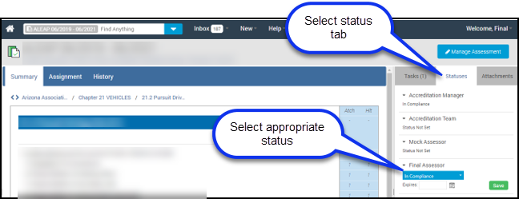

6. If you entered a simple note to list a deficiency or to recommend a corrective action, you have the option to set the status of the standard to “Not in Compliance” and expire the status based on the time frame discussed with the agency. Once the agency passes the due date, the status of the standard will revert to “Not Set” and the task will drop into your inbox. This can be a reminder that you need to review that standard to reassess the agency’s compliance.

B. Adding Simple Notes

Simple Notes can act to document findings during the file review. These notes can be exported into a Word, Excel, or PDF document and saved for completing reports for the Utah Accreditation Alliance.

To add a Simple Note:

1. Navigate to the Attachments tab of the standard.

2. Select Add New Attachment

a. From the Type drop-down list, select Simple Note

b. Type your notes in the space provided.

c. Map (or anchor) the Simple Note to the appropriate level of the standard (or bullet point).

d. Click SAVE when you are finished.

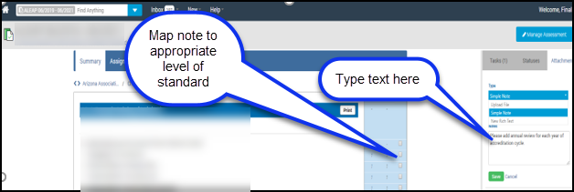

Your added note will appear at the bottom of the list of attachments in the right pane (below the agency’s attachments).

V. Reports

Typically, the agency does not give assessors access to the PowerDMS Report feature. However, you can ask the agency’s project manager to run a Status Report for One Role report specifically for the UAA Assessor or Mock Assessor role.

To access all the Simple Notes added by an assessor, the assessor can filter all of the assessment’s attachments for SIMPLE NOTES by UAA Assessor role (or Mock Assessor role) to generate a report of the Simple Notes (or findings) added during the file review.

To export assessor Simple Notes:

1. Navigate to the root of the manual, or chapter header to filter for Simple Notes by Chapter.

2. Click on the ATTACHMENTS tab

3. Select the SIMPLE NOTES from the Attachment Type drop-down menu from the filters at the top of your screen

4. Select UAA (or Mock) ASSESSOR role from the Added by Role drop-down menu

5. Click the Filter button

6. Select the preferred file type icon for export (Excel, Word, PDF) in the upper right-hand corner of the table.

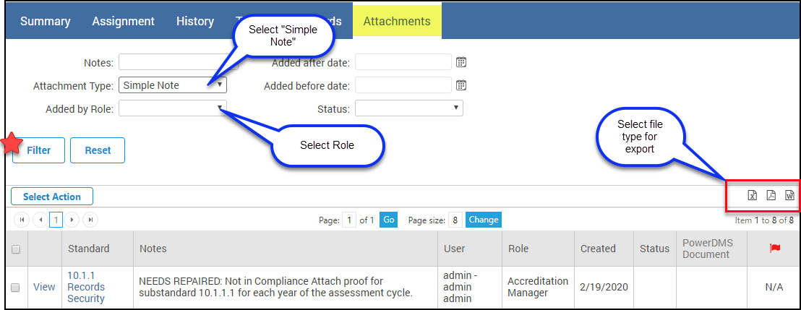

VI. Help and Support

The PowerDMS assessment tool can be used in many ways. Choose the method that works best for your team and be consistent.

The PowerDMS Service Desk Support can be reached by calling (888) 959-5158 or by e-mailing support@powerdms.com Monday through Friday, from 8:00 a.m. to 5:00 p.m. Eastern time.

Don’t get stuck or frustrated - reach out, we are happy to assist!

For more information, see Conducting an Assessment in PowerDMS for a video tutorial and the Article Conducting a Mock and Final Assessment.

